Data2Donors - Tracking New Names and Addresses
As part of the Data2Donors program, camps will enter new names and updated addresses into their databases. Records that are updated should be tracked consistently so they can be segmented. Every database has functionality to easily categorize records so that they can be segmented for reporting and communications. DonorPerfect Online (DPO) uses Flags (see image below); other systems use Tags or other features to categorize records in the database.

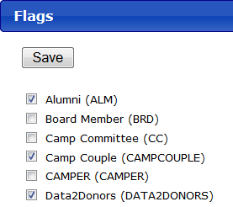
For every new name or updated address added to the database during Data2Donors, please track them consistently. This will allow you to:
- Ensure you send a welcome email or packet to every constituent you reconnect with during this process.
- Allow you to report on the success of your work in Data2Donors.
You can track them as “Data2Donors” or in any other way that will allow you to easily pull a list of these new records.
Questions? Contact Kevin at kevin@hgf.org.

