Nourishing Ourselves:
The Art of Leadership

Facilitator:
Rabbi Yafa Chase

Please read sources 1 and 2 together
Source 1: Exodus, Chapter 18, Yitro
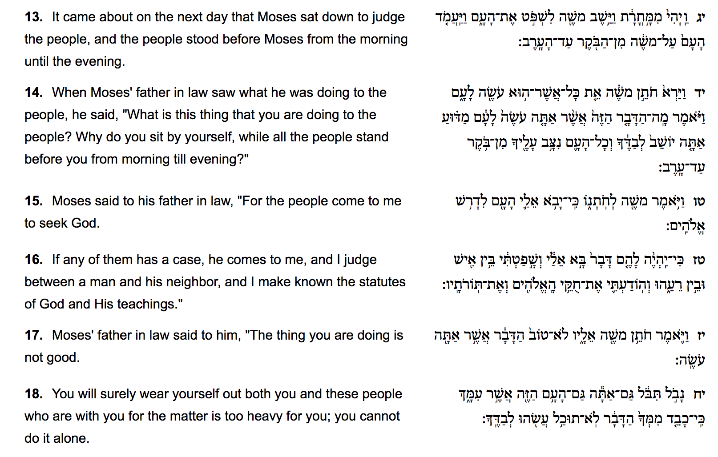

Quick Facts:
Yitro was Moshe’s father in law.

Thought Questions:

- What was Moshe’s task as the text describes it?
- What part of Moshe’s actions is Yitro questioning?
- Are here moments in your work when you need the voice of Yitro?
Source 2
Rabbi Jonathan Sacks (1948-present) is a British rabbi, philosopher, author, and politician.
Rabbi Sacks
No one can lead alone. Seven times in Genesis 1, we hear the word tov, “good.” Only twice in the whole Torah does the phrase lo tov, “not good,” appear. … The second is when Yitro sees his son-in-law Moses leading alone, and says, “What you are doing is not good.” We cannot live alone. We cannot lead alone. Leadership is teamsmanship.
One corollary of this is that there is no one leadership style in Judaism. During the wilderness years there were three leaders: Moses, Miriam and Aaron. Moses was close to God. Aaron was close to the people. Miriam led the women and sustained her two brothers. The sages say it was in her merit that there was water to drink in the desert.
During the biblical era there were three different leadership roles: kings, priests and prophets. The king was a political leader. The priest was a religious leader. The prophet was a visionary, a man or woman of ideals and ideas. So in Judaism leadership is an emergent property of multiple roles and perspectives. No one person can lead the Jewish people.
“Seven Principles of Jewish Leadership”
http://rabbisacks.org/seven-principles-of-jewish-leadership-written-for-the-adam-science-foundation-leadership-programme/

Thought Questions:

- How would you describe your own leadership style?
- Can you think of any examples from your work where you benefit from the idea that “leadership is teamsmanship”?

Please read sources 3 and 4 together
Source 3: Exodus Rabba 5:9
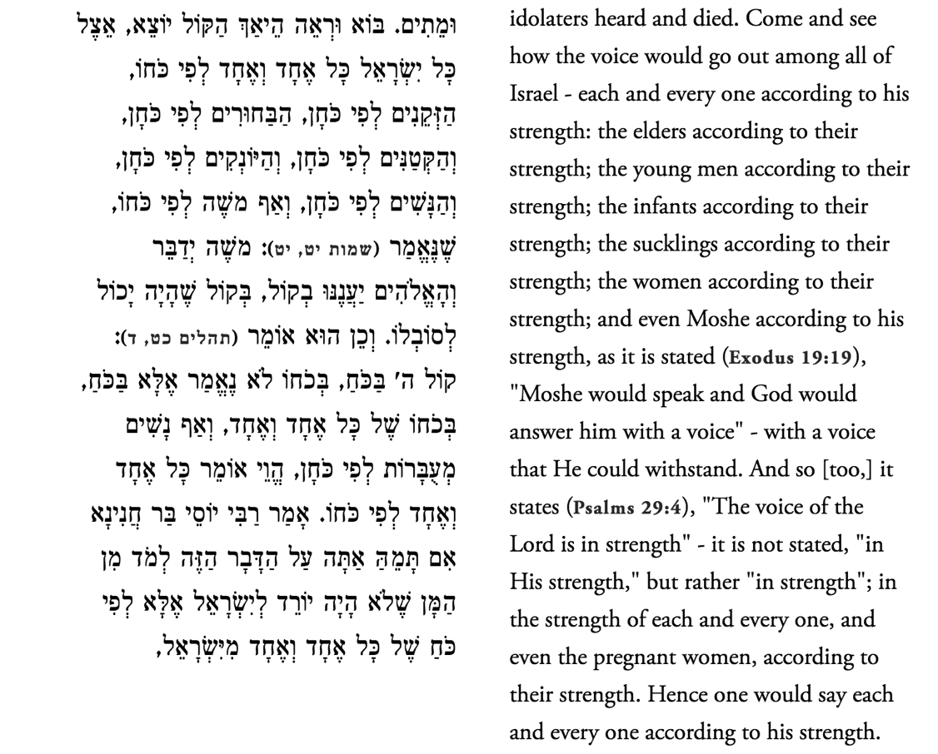

Thought Questions:
- How do you interpret this text?
- Where, according to this text, is the voice of G-d found?

Source 4: Parker Palmer (1939-present) is an American author, educator, and activist
“’Leadership’ is a concept we often resist. It seems immodest, even self-aggrandizing to think of ourselves as leaders. But if it is true that we are made for community, then leadership is everyone’s vocation, and it can be an evasion to insist that it is not. When we live in the close-knot ecosystem called community, everyone follows and everyone leads.”

Thought Questions:
- What do you think of Palmer’s suggestion that “if we are made for community, then leadership is everyone’s vocation?”
- Can you think of a time when have you followed the leadership of another?
- Can you think of a time when you empowered another to lead?
Please read sources 5 and 6 together
Source 5: Shemot 11/Numbers 11

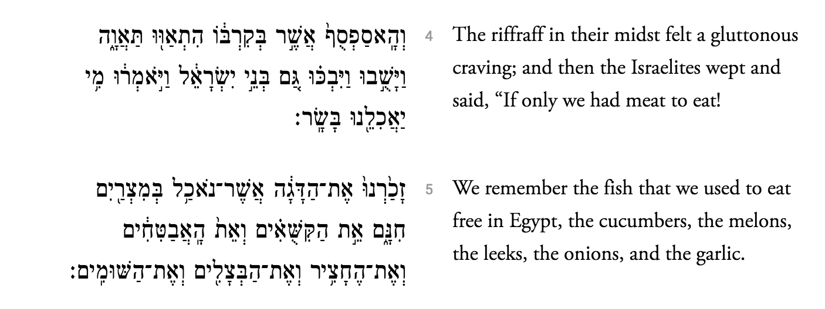

Thought Questions:
1. What happened to Moses the leader here?
2. Can you relate to what he is experiencing?
3. What does this text tell us about making change?

Source 6: Rabbi Jonathan Sacks

“In short, leadership is not simple. It is complex because it involves people and people are complex. You have to listen, and you have to lead. You have to strive for consensus but ultimately, if there is none, you must take the risk of deciding.”

Thoughts Questions:
- Do you agree with this statement? Why or why not?
- How does the act of listening help you with your PJ work?
- Have you ever felt this tension between wanting consensus but needing to take action – or vice versa – seeing action happening but wanting consensus?

IF YOU HAVE TIME...Source 7

Isaac Luria “boldly suggests that creation begins with an act of contraction, tzimtzum. God does not initiate the existence of other things by extending himself. There would be no place for them then to be, no area of non-being or partial being in which they might exist. Hence to create, he must first withdraw into himself. God must, so to speak, make himself less than he is so that other things could come into being. So great, says Luria, is God’s will to create; so great is his love for creation… For Luria … God concentrates himself not out there, at a point in the world, but within himself. By this act he leaves a void in which his creatures can come into being.”

“Think of the sort of leadership we have all known in groups of small to moderate size, the family, the classroom, the church or synagogue … These institutions have goals to accomplish. Yet in being part of them, it has made all the difference in the world to us whether we felt our parents or teachers or clergy were using us to accomplish their purposes or helping us grow as we labored for our common ends. I suggest that the ability to practice tzimtzum can sharply distinguish accomplishment-directed from person-fostering leadership. (In traditional models of leadership,) Leaders, by their power, have a greater field of presence than most people do. When they move into a room they seem to fill the space around them. We say they radiate power. Hence the greater the people we meet the more reduced we feel …

(However) the Lurianic model of leadership has, as its first step, contraction. The leader withholds presence and power so that the followers may have some place in which to be.”

From Eugene Borowitz (1974), “TzimTzum: Model for Contemporary Leadership”, Religious Education 69(6): 687-700

Talmud Yoma 2

Quick facts: Isaac Luria lived in Safed (1534-1572). He is also known as Ha’Ari or the Arizal. He was a Rabbi and mystic, known for being the father of kabbalah.
Thoughts Question:
- How is Lurianic leadership different to traditional models of leadership?
- Where in your work have you needed “accomplishment-directed leadership” and where in your work have you engaged in “person-fostering leadership”?

Think about what you want to learn at the conference – some of the workshops are really about values and empathy and some of them are about technical skills – what kind of balance are you looking for?

