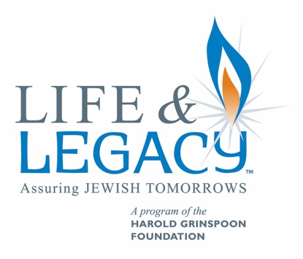
Tips for Legacy Conversations

Call to schedule an appointment:
  - Introduce yourself and your affiliation with the organization.
  - Thank them for their support of your organization and request a meeting to learn more about why they are committed to your organization and to share with them the difference your organization is making in the community.
  - Set up a time and place to meet (wherever and whenever is best for them).
  - Let them know if someone else will be joining you.

After thanking them for meeting you and a little chit chat, ask a question:
  - When you think about Jewish (your community) 40 years from now, what do you envision?
  - When and why did you make your first gift to (organization)?
  - Why have you chosen to be a loyal donor?
  - What is the most meaningful experience you have had at (organization)?
  - What are your favorite things about (organization)?
  - What are your dreams for the future of (organization)?

Focus on the Donor:
  - Listen to what they are saying.
  - Attempt to understand their commitment to your organization beyond your “good work.”
  - Take cues from them to move the conversation forward.
  - Look for ways to acknowledge, affirm and agree with what they are saying…avoid saying “no” or “but.”

Wait until time is right:
  - Whatever you hear – accept it and use to navigate through the rest of the conversation.
  - Focus on their connection to the organization, not what your organization needs.
  - If donor presents you with an unanticipated situation (upset at organization for some reason, financial challenges) don’t get upset, work with the information provided.
  - Only ask about a legacy commitment when the donor seems ready to hear it.

Share your case statement:
  - Why legacy support is important.
  - The organization’s vision for the future.
  - Why you decided to make your legacy gift
  - Explain the incentive grant opportunity (during the time period when incentive grants are offered)

Invite them to partner with you:
  - Will you join me in making a legacy commitment?
  - Be Quiet – allow them time to respond – silence is not the enemy here.
Be prepared to respond:
  - YES – Great! Thank you them and review the Letter of Intent form. Explain the opportunity to also choose other organizations.
  - MAYBE – Give them a chance to explain their hesitation. Ask if there is any additional information you can provide them that would help them with the decision. Set up another time to meet with them, or for a follow-up phone conversation if they need to discuss with spouse or have other issues they want to look into.
  - NEED MORE TIME - give them a chance to explain their hesitation. Set up another time to meet with them, or for a follow-up phone conversation.
  - NO – ask them why and depending on the reason, ask if it would be ok to follow up with them in 6 months or next year.

No matter the outcome, always thank your donor
- Send a handwritten note after the meeting to again thank them for having a conversation with you.
- If they agreed to have you follow-up with them, make sure you remind them in the note.

Overcoming Objections:
“The economy is doing poorly and I don’t have enough money right now.”
- A legacy pledge can be made now and does not require any money at the present time. It is an after-lifetime gift.
“I would love to make a large gift, but I want to make sure my children are provided for.”
- An estate plan that includes your children and other charities you care about can ensure that your children receive an inheritance at the same time as your personal charitable values are honored.
“I am not wealthy. Legacy gifts are for the rich.”
- A legacy gift can be made by anyone and be for any amount.
“I don’t have any family, so I don’t need to think about gift and estate planning.”
- State laws will determine the disposition of your estate if you don’t have a plan in writing. Even if you don’t have a family, you should still create an estate plan that reflects the things you care about.

