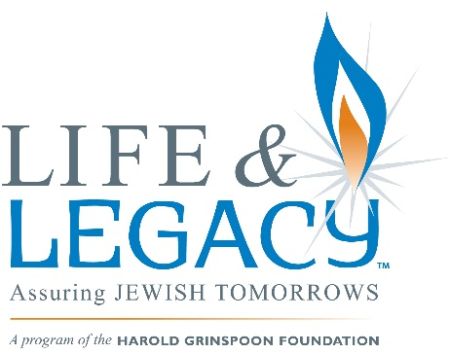(add additional logos here if you wish or put logos on bottom)
Legacy Gift Confirmation

I/We, , of , confirm that I have
(Name) (City) (State)
legally provided for my commitment to the (Name of program) of (community)
for the benefit of the following organization(s):

I have provided for this gift within my estate plan and confirm that I have made the appropriate legal arrangements to assure that this will be accomplished on or about the time of my passing. I have currently provided that my commitment is acknowledged within the following document:

Bequest in Will
Charitable Remainder Trust

Beneficiary of a Life Insurance Policy Charitable Lead Trust
Beneficiary of a Retirement Plan Cash Endowment Gift
Charitable Gift Annuity (CGA) Other (please describe):

I am pleased to be able to support the Jewish community in (community) through my legacy gift. The approximate value of my commitment will be $ or % of my/our estate.

Donor Signature Date

Donor Signature Date

OPTIONAL: Assistance to provide for my legacy commitment given by (Please designate adviser):

My estate planning attorney is: My financial planner is:
Phone: Phone:

Other:

LIFE & LEGACYTM is sponsored and presented by (name of lead organization) and is a collaborative effort of the following area agencies, synagogues and day schools: (list organizations or print logos)

If you have not already submitted confirmation of your legacy gift, PLEASE COMPLETE & RETURN THIS FORM TO:
(contact information)

