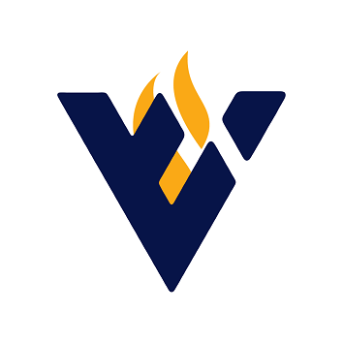
Schechter Spark Talking Points for Board Members

Note: Schechter Spark was a planned in-person fundraising event that the camp has decided to transition to a virtual event.

- How are you and your loved ones? We know that this is an unprecedented time for many families.

- Schechter Spark is moving online due to COVID-19. We are excited that all of our supporters, no matter where they live, can now be part of our program.

- On Sunday, May 3 from 11:00 am – 11:45 am, we ask that everyone tune in on Zoom.

- Our program will also include the last interview with Rabbi Stampfer, z"l, talking about camp. His words will give us the strength to get through these difficult times.

- All donations will be matched dollar for dollar, up to $100,000 by our Matchmakers: Audrey Covner and Dianne Dougherty, Joann and Carl Bianco, Becky and Lee Holzman, and The SAMIS Foundation

- The Harold Grinspoon Foundation is donating 10 million to Jewish Camps with match challenges – we are part of that match. Your donation will go even further.

- Elana Stampfer Emlen will accept the Migdal Or award on behalf of her parents, Rabbi Joshua and Goldie Stampfer, z”l.

- We promise that the program will put a smile on your face.

- The support of our community is more vital than ever due to the challenges arising from the pandemic. We need your help to ensure that every camper family who wants to benefit from the Schechter experience can participate this year without their financial situation being a barrier. Your support is an investment in our community’s future and ensures that Camp Solomon Schechter can be as inclusive as possible.

- In the midst of the pandemic, we need additional support to ensure the safety and health of our campers and staff, while ensuring the survival of the camp.

- We ask all of our supporters to be the spark, light the way

- If you would like to make a gift now, please go to the camp website <campwebsite.org>

- For more information, contact <contact name> <email address> <phone number>

