November 26, 2012

«TITLE»«FIRST_NAME» «LAST_NAME»

«SPFNAME» «SPLNAME»

«OPT_LINE»

«ADDRESS»

«CITY», «STATE» «ZIP»

«COUNTRY»

Dear «SALUTATION»:

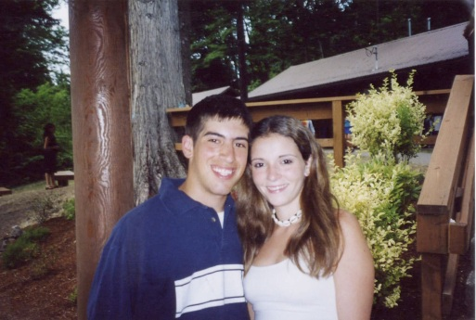What is your most vivid camp memory? Mine comes from my Mt. Rainier Trip. I will never forget sitting around the campfire with my fellow Odedim – campers with whom I had spent the past eight summers. We were reminiscing over our years as campers, singing the songs we had grown to love, roasting kosher marshmallows to make s’mores, and boisterously showing our camp *ruach* (spirit). It was the perfect finale of my years as a camper . . . a rite of passage, if you will, that marked my transition from energetic camper to dedicated counselor. I should also mention that my wife, Rachel Cohen, was in this group, and although we had been going to Schechter together for years, we did not “meet” until that summer.

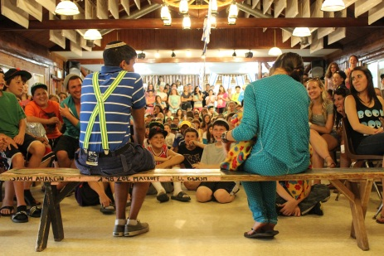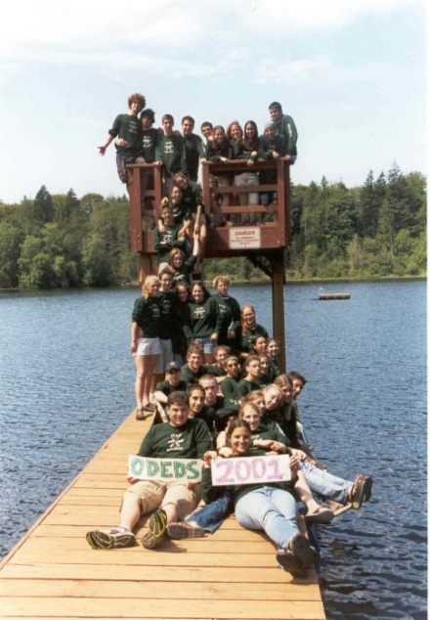I am amazed by how much Jewish knowledge stuck with me from the incredible “informal” education we received. Who can forget Cupcake Theatre?!? For those who have not experienced it, Cupcake Theatre is a skit every Shabbat based on the Torah portion for the week, and, afterwards, we eat cake . . . such a fun way to learn Torah! My first exposure to Israeli culture was through the Israeli Scouts. The Caravan’s singing and dancing were great, but having a co-counselor from Israel was a remarkable learning experience. I often find myself singing camp tunes for prayers when I am at synagogue and fondly remember the countless *Shira* (singing) sessions. More importantly, camp has always been and will always be a place where Jewish kids can learn about and practice Judaism in a personally meaningful way.

I am grateful to my parents, Alan & Suzanne, for giving me the gift of MY camp memories. They know, first hand, what a gift this is since they both went to Schechter when they were kids. If not for camp, they may never have met. My memories have shaped me as a Jew and encouraged me to become a leader in the Jewish community.

I am writing today to ask you to join me in giving the gift of camp memories to the campers of today. By making a contribution to Schechter, you are supporting the next generation of Jewish leaders in our community. $118 gives a camper a day at camp; $1,180 sponsors a first time camper; and $2,530 pays for a session for a camper. Thank you for your generous support to provide cherished camp memories to our future leaders.

Sincerely,

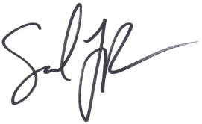

Sam Rubens

Camper ’93-‘00, Oded ‘01, Counselor ’02-‘03,

Current Board Member and Future Camp Parent