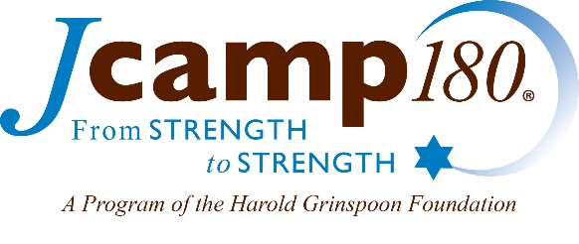

- Program Goals

Board2Board Camp Visits Program Description

The Board2Board Camp Visit Program is designed to support members of overnight or day camp boards visiting each other’s camps during the Summer or during the offseason if that would better help participating camps to reach their program goals. The goals are to promote Board members’ learning about other camps, share experiences, best practices and lessons gained in their volunteer camp journeys, and strengthen their personal and professional camping networks.
In addition to touring camps, priority will be given to applications that will be exchanging information on the topics of strategic planning, governance and board development, fund raising, enrollment and alumni outreach. Some camps also may wish to use the opportunity to explore the potential for collaboration in programming, staffing or other areas. Although the primary focus is on Board member to Board member connections, the participation of Camp Directors and/or senior staff also could be integral parts of any visits.
- Program Options

  - Peer to Peer –Two or more Board members from one camp visit and tour a second host camp where they meet with two or more Board members from that camp. They share experiences and lessons and possibly explore opportunities for collaboration.

  - Group Visit –Two or more Board members from each of three to ten camps arrange to visit and tour one or more host camps and, using a structured agenda, share experiences, lessons and even explore opportunities for collaboration. A third‐party organization (e.g. a movement or federation camping unit) could co‐ordinate this program and participate.

  - Other – JCamp 180 is open to variants of these options or even other approaches which accomplish the same goals. Please feel free to contact JCamp 180 ‐ Sarah Eisinger (seisinger@hgf.org, 413‐276‐0779).

JCamp 180 mentors are available and pleased to discuss how the Program could be useful to your camp, help plan the Program and, if available, serve as an in‐person resource and/or facilitator for a group of camps. Mentors can also make suggestions to match camps with similar needs.
- Program Guidelines

JCamp 180 is pleased to provide incentive grants to support JCamp 180 camps participating in Board2Board visits and to offset some (but not necessarily all) the costs of travel, accommodation and hospitality.

This Program is intended to promote and support new connections between Board members and camps and cannot be used to fund existing programs where Board members of camps (e.g., with common affiliations) convene. However, it can fund new initiatives focused on Board members of camps which are affiliated or not affiliated with each other.
Camps and participants will make all their own travel and accommodation arrangements.
Non‐JCamp 180 camps can participate (if a minority of participants) but will not have any expenses reimbursed.
Camps are encouraged to participate in site visit programs outside of their immediate geographical area.
Please respond by the application deadline, which can be found on our website.
JCamp 180 will review and respond to the application in a timely manner, well in advance of the summer, to allow camps to make travel arrangements. Based on JCamp 180’s review, some adjustments may be requested.
Applications will be competitively reviewed; camps will be notified of their status shortly after the application deadline.
In evaluating the applications, the following will be considered:
- Filling a special need or gap in camp and their board member connections
- Number of participating camps and Board members
- Design of activities
- Willingness to share learnings

Funding reimbursement must be approved prior to travel taking place and approved applicants will be notified within one week of their application.
Participants must submit a written report upon completion of the program to JCamp 180 summarizing the exchange including findings, learnings, and future actions that result from the visit. This report may take the form of their choosing but must be submitted to JCamp 180 within 60 days of completing the exchange.
- Reimbursement Guidelines

Camp Board members will make all their own travel arrangement. The JCamp 180 grant is meant to supplement but not necessarily completely cover the costs of travel. Camps can only be funded for one Program during the summer.

Reimbursement will be at a rate of 50% of all qualified and approved expenses up to a maximum reimbursement of $2,000 per person or $5,000 per camp.

Reimbursement will be made to the camp on behalf of its travelers. Each camp must submit a single reimbursement form by mail within 60 days of the camp visit. The submission must include receipts for all expenses being submitted for reimbursement. Receipts must be originals and should be clearly marked to indicate which person on your team incurred each expense.

