December 2, 2013
«TITLE»«FIRST_NAME» «MIDDLE_NAME»«LAST_NAME»
«SPFNAME»«SPLNAME»
«OPT_LINE»
«ADDRESS»
«CITY», «STATE» «ZIP»
«COUNTRY»

Dear «SALUTATION»:

Shalom from G1 at Camp Solomon Schechter! The end of camp is only two days away, and we realize you won’t even receive this letter for several months. But, we wanted to take a few minutes to write to you as a Friend of Schechter. . . to let you know how much your investment in Schechter means to all of us campers and summer staff.

We could write for hours about all of the fun stuff we do at camp – art, sports, teva, boating, Peulat Sababa, zip tour, challenge course, climbing wall, evening programs, Yom Y’srael, and the list goes on and on – but what really matters is that at Schechter we can truly be ourselves! It is a comfortable and safe place to spark our creativity, fuel our curiosity, explore our culture and religion and forge lasting friendships with fellow campers and staff from throughout the Pacific Northwest, Israel and beyond.

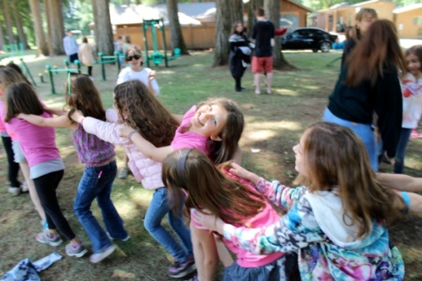
The highpoint of this is Shabbat, which is so special at camp. It begins with getting dressed up and meeting on The Hill for pictures with friends. We then go to services where we gain a deeper understanding of Judaism while having a blast – singing, dancing and adding a touch of humor to our prayer. This is followed by Shabbat dinner and a shira (singing) session so loud and enthusiastic the Chadar Ochel (dining hall) shakes from the noise! We go to bed tired, feeling the warm glow of our camp ruach (spirit) in our hearts. Saturday is spent with our friends leading to the ultimate feeling of togetherness at Havdalah, the likes of which we don’t see outside camp.

We are asking you to make a contribution to Schechter to ensure that every Jewish kid in our community gets the opportunity to not only experience all of the fun stuff, but also the closeness and spirit of a camp Shabbat. Those who struggle to afford camp need it the most . . . a place that is safe, has a strong feeling of togetherness, where each of us can truly be ourselves.
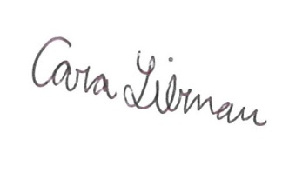
Sincerely,

Yael Egnal Cara Libman
Camp Counselor, G1 Gimmel Camper, G1

PS: We found out from Sam and Furman that the average scholarship to a camper in need is $300, so please consider supporting one or more of our fellow bunkmates for 2014!

